As of 9-28-05

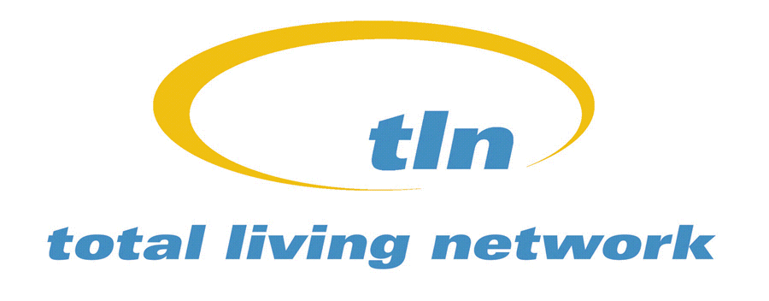

Chicagoland
Channel Listings

Insight Communications
Dixon 63
La Salle 63
Ladd 63
Mendota 63
North Utica 63
Oglesby 63
Peru 63
Spring Valley 63
Sterling/Rock Falls 63

Comcast Cable

Addison 98
Algonquin 71, 74
Alsip 71
Antioch 75
Arlington Heights 65
Aroma 71
Aroma Park 71
Ashkum 71
Aurora 74
Bannockburn 75
Barrington 24
Barrington Hills 71
Bartlett 65
Batavia 74
Beach Park 75
Bedford Park 98
Beecher 71
Bellwood 98
Bensenville 98
Berkeley 98
Berwyn 98
Beverly Shores, IN 60
Bloomingdale 98
Blue Island 71
Bolingbrook 67
Boulder Hill 74
Bourbonnais 71
Bradley 71
Braidwood 67
Bridgeview 98
Bristol 74
Broadview 98
Brookfield 98
Buffalo Grove 67
Burbank 98
Burnham 71
Burns Harbor, IN 60
Burr Ridge 98
Calumet City 71
Calumet Park 71
Carbon Hill 67
Carol Stream 98
Carpentersville 71
Cary 71
Cedar Lake, IN 60
Channahon 67
Chebanse 71
Chesterton, IN 60
Chicago
Areas 1, 4, 5 14
Chicago
Areas 2, 3 86
Chicago Heights 71
Chicago Ridge 71
Cicero 98
Clarendon Hills 98
Clifton 71
Coal City 67
Country Club Hills 71
Countryside 98
Countryside Estates 74
Crest Hill 67
Crestwood 71
Creston 73
Crete 71
Crown Point, IN 60
Crystal Lake 71
Custer Park 67
Darien 98
Deer Park 24
Deerfield 75
DeKalb 73
Delmar Woods 75
Demotte, IN 60
Des Plaines 65
Diamond 67
Dixmoor 71
Dolton 71
Downers Grove 98
Dune Acres, IN 60
Duneland Beach 60
Dyer, IN 60
East Chicago 19
East Dundee 71
East Hazel Crest 71
Elgin 71
Elk Grove Village 67
Elmhurst 98
Elmwood Park 98
Evanston 98
Evergreen Park 71
Flossmoor 71
Ford Heights 71
Forest Park 98
Forest View 98
Fort Sheridan 75
Four Lakes 74
Fox Lake 75
Fox River Grove 71
Frankfort 67
Franklin Park 98
Gary, IN 19
Geneva 74
Glencoe 75
Glendale Heights 98
Glen Ellyn 74
Glenview 65
Glenview Naval Air Station 65
Glenwood 71
Golf 65
Goose Lake 67
Grayslake 75
Great Lakes
Naval Center 75
Green Oaks 75
Griffith, IN 60
Grundy 67
Gurnee 75
Hainesville 71
Hammond, IN 19
Hanover Park 65
Harvey 71
Harwood Heights 98
Hawthorn Woods 24
Hazel Crest 71
Hebron, IN 60
Herscher 71
Hickory Hills 71
Highland, IN 60
Highland Park 75
Highwood 75
Hillcrest 73
Hillside 98
Hinsdale 98
Hobart, IN 60
Hodgkins 98
Hoffman Estates 67
Holiday Hills 71
Homer Twnshp 67
Hometown 71
Homewood 71
Huntley 71
Indian Creek 24
Indian Head Park 98
Inverness 67
Island Lake 71
Itasca 98
Jasper, IN 60
Johnsburg 71
Joliet 67
Justice 98
Kankakee 71
Kendall (NE) 74
Kenilworth 75
Kildeer 24
Kingsbury, IN 60
Kingsford Hts, IN 60
LaGrange 98
La Grange Park 98
Lake 71, 75
Lake in the Hills 71
Lake Barrington 24
Lake Bluff 75
Lake Forest 75
Lake Holiday 74
Lake of 4 Seasons, IN 60
Lake Station, IN 60
Lake Villa 75
Lake Zurich 24
Lakemoor 71
Lakewood 71
Lansing 71
LaPorte, IN 60
Lemont 67
Libertyville 75
Lily Lake 74
Limestone 71
Lincolnshire 75
Lincolnwood 98
Lindenhurst 75
Linnwood (unincorp) 67
Lisle 74
Lockport 67
Lombard 98
Long Beach, IN 60
Long Grove 24
Lowell, IN 60
Lynwood 71
Lyons 98
Maine 98
Manteno 71
Markham 71
Matteson 71
Maywood 98
McCook 98
McCullom Lake 71
McHenry 71
Melrose Park 98
Merrillville, IN 60
Merrionette Park 71
Michiana Shores 60
Michigan City, IN 60
Midlothian 71
Minooka 67
Mokena 67
Monee 71
Montgomery 74
Morris 67
Morton Grove 98
Mount Prospect 65
Unincorp. Mt.Prospect
67
Mundelein 75
Munster, IN 60
Naperville 74
New Buffalo Twnshp, MI 60
New Chicago, IN 60
New Lenox 67
New Trier 98
Niles 98
Norridge 98
North Aurora 74
North Barrington 65
North Chicago 75
North Riverside 98
Northbrook 65
Northfield 98
Northlake 98
Northlake (unincorp.) 71
Norwood Park Twp
67
Nottingham Park 67
Oak Brook 98
Oakbrook Terrace 98
Oak Forest 71
Oak Lawn 71
Oak Park 98
Oakwood Hills 71
Ogden Dunes, IN 60
Ogle 73
Olympia Fields 71
Orland Hills 71
Orland Park 71
Oswego 74
Otto 71
Palatine 67
Palos Heights 71
Palos Hills 71
Palos Park 71
Park City 75
Park Forest 71
Park Ridge 65
Peotone 71
Phoenix 71
Plainfield 67
Plainfield Tnshp 67
Plano 74
Port Barrington 71
Portage, IN 60
Porter, IN 60
Posen 71
Pottawattamie Park,IN 60
Prairie Grove 71
Prospect Heights 65
Proviso 98
Richton Park 71
River Forest 98
River Grove 98
Riverdale 71
Riverside 98
Riverwoods 75
Robbins 71
Rochelle 73
Rockdale 67
Rogers Park 37
Rolling Meadows 67
Romeoville 67
Roselle 98
Rosemont 98
Round Lake 71
Round Lake Beach 71
Round Lake Heights71
Round Lake Park 71
Sandwich 74
St. Anne 71
St. Charles 74
St. John, IN 60
Sauk Village 71
Schaumburg 65
Schererville, IN 60
Schiller Park 98
Shorewood 67
Shorewood, IN 60
Skokie 65
Sleepy Hollow 71
South Barrington 71
South Chicago Heights 71
South Elgin 71
South Holland 71
Steger 71
Stickney 98
Stone Park 98
Streamwood 65
Summit 98
Sun River Terrace 71
Sycamore 73
The Pines, IN 60
Third Lake 75
Thornton 71
Thornton Twp. 71
Timber Creek Tr. Park 71
Tinley Park 71
Tower Lakes 65
Trail Creek. IN 60
Troy 67
University Park 71
Valparaiso, IN 60
Vernon Hills 24
Villa Park 98
Volo 71
Wadsworth 75
Warrenville 74
Wasco 71
Wauconda 75
Waukegan 75
West Chicago 74
West Dundee 71
Western Springs 98 Westchester 98
Westmont 98
Wheaton 74
Wheatland 67
Wheeling 65
Whiting, IN 60
Wildwood
Communities 74
Willowbrook 98
Willow Springs 98
Wilmette 98
Wilmington 67
Winfield 74
Winfield, IN 60
Winnetka 75
Winthrop Harbor 75
Wonder Lake 71
Wooddale 98
Woodridge 98
Woodstock 71
Worth 71
Wrigleyville 37
Yorkville 74
Zion 75

Illinois and Indiana Counties
Channel Listings

Comcast Cable
Cook (unincorp. IN) 65, 67, 71, 75
DuPage (unincorp.) 98, 74
Iroquois 71
Kane (unincorp) 71, 74
Lake (unincorp. IL) 24, 65, 71,75
Lake (unincorp. IN) 60
Porter County 60
Will (unincorp.) 60, 67, 71, 74

*TLN may not be available in all neigborhoods.

